**Assignment**

**Name:** Muhammad Fahad

**ID:** FA19-BSSE-0014

**Course:** DCN Lab

**Section:** BM

**Teacher:** Sultan Ahmed Khan

|  |  |  |  |
| --- | --- | --- | --- |
| Network |  |  |  |
| 1 | 192.168.Batch.ID | 192.168.19.14 | 192.168.19.15 |
| 2 | 192.168.(Batch + 10).(ID + 1) | 192.168.29.15 | 192.168.29.16 |
| 3 | 192.168.(Batch + 15).(ID) | 192.168.34.14 | 192.168.34.15 |
| 4 | 192.168.(Batch + 29).(ID + 3) | 192.168.48.17 | 192.168.48.18 |
| 5 | 192.168.(Batch + 11).ID | 192.168.30.14 | 192.168.30.15 |

|  |  |  |  |  |
| --- | --- | --- | --- | --- |
|  |  |  |  |  |
|  |  | IP Address | RIP | PC |
| R0 | G0/0 | 192.168.19.14 | 192.168.19.0 | 192.168.19.15 |
| G0/1 | 192.168.29.14 | 192.168.29.0 |
| G0/2 | 192.168.48.17 | 192.168.48.0 |
| R1 | G0/0 | 192.168.29.15 | 192.168.34.0 |  |
| G0/1 | 192.168.34.15 | 192.168.29.0 | 192.168.29.16 |
| G0/2 | 192.168.30.14 | 192.168.30.0 |  |
| R2 | G0/0 | 192.168.48.18 | 192.168.48.0 |  |
| G0/1 | 192.168.30.15 | 192.168.30.0 |  |
|  |  |  |  |  |

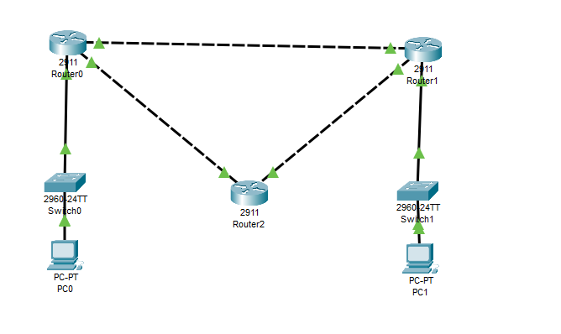

# PC 0 to PC 1

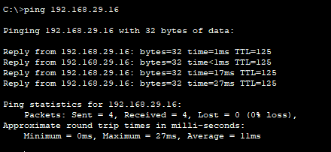

# PC 1 to PC 0

